**Alex Hankin/Naropa Perez**

CSC 252

MIPS Emulation

Write Up

1. **Overview**

For this project we create a MIPS emulator in C. We use numerous given C files, along with manipulating a specific C file, in order to encode our emulator. The emulator runs through hexadecimal files, which can be read as an assembly language through our C emulator and run the instructions appropriately.

1. **File’s results**

**Tier 1-**

Arith-

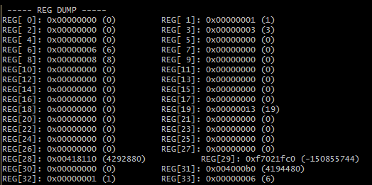

Branchtest-

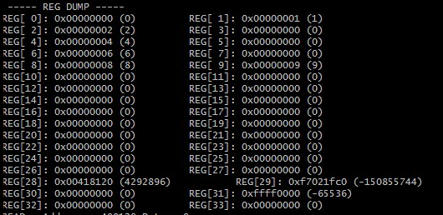

Hilo-

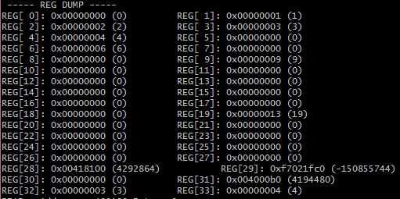

Linktest-

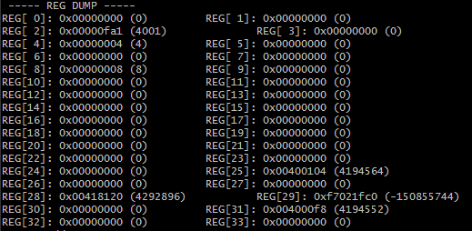

Systest-

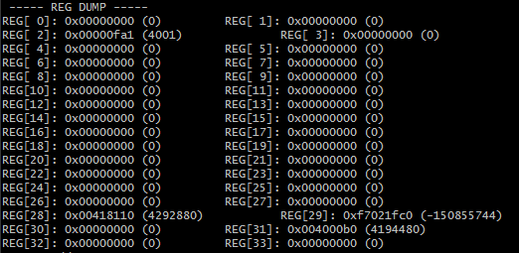

Zero-

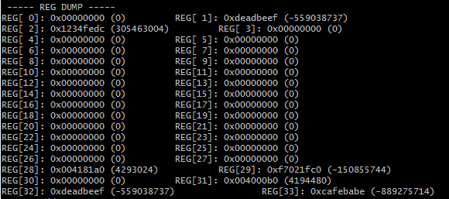

**Tier 2-**

BinarySearch-

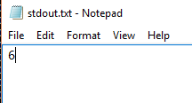

6th slot. (starts at 0, location of 7 in a 1-10 list)

MatrixMultiplication-

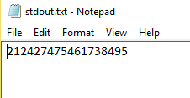

Matrix:

|21 24 27|

|47 54 61|

|73 84 95|

MinMaxMedian-

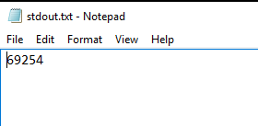

Min: 6 Max:92 Median:54

**Cpp-**

Class-

Hello-